Main Agenda- To create a data transform to print a sequence based on the input

To achieve this requirement we need to follow the following steps.

I created a case type called as Print Sequence

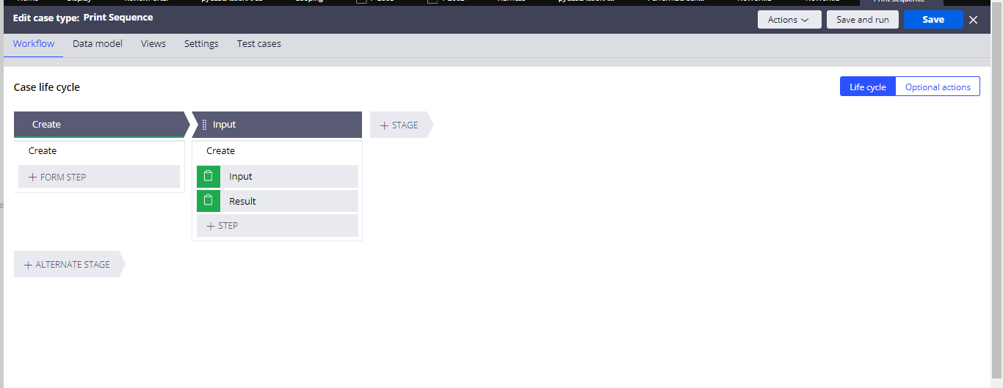

In here we have created 2 properties named first number and last number

And one more called as Result as the text type

And in order to do the sequence we would need Data transform

Now in here let us go for the data transform thing in depth

So in the first line we can apply when condition as firstnumber < lastnumber

And in the second step take as result and then we can go for the

Result = Result + FirstNumber + “,”

And the next step would be

Set FirstNumber = FirstNumber+2

And in the next step apply the next data transform as the same name and do the exit data transform

And again

In the last step since we don’t want concatenation on the last digit so we can use the function whatComesBeforeLast and my property and concatenation

whatComesBeforeLast(.Result,',')

and when we do the input

Output

